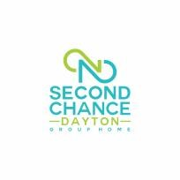Second Chance Dayton Group Home LLC | Community Engagement Plan
Policy And Procedure | Effective Date: May 1, 2023
Any person or entity with concerns or other pertinent information regarding Second Chance Dayton is encouraged to contact the agency directly through the following channels.
 | Second Chance Dayton Contact Information
Second Chance Dayton Administrator/ Director |  | Marquita Lynch |  | (937) 248-5162
 | M.lynch@secondchancedayton.org
 | Second Chance Dayton General Information
1358 Canfield Ave  Dayton, OH 45406  411 Marathon Ave  Dayton, OH 45406  1438 Kumler Ave  Dayton, Ohio 45406  3641 Brumbaugh Blvd  Trotwood, Ohio 45416 |  | Office@secondchancedayton.org |  | (937)-248-5162
 | Secondchancedayton.org

- All community concerns, requests or information received will be directed to the Administrator, who will respond within 10 business days.

- Second chance Dayton will fully cooperate with any law enforcement investigations, as directed by the law enforcement agency.

- In the event that the Administrator is the subject of a complaint or is unable to respond to the communication, the Second Chance Dayton Board President will respond.

- Second Chance Dayton will provide a copy of this Community Engagement Plan to any individual upon request.

