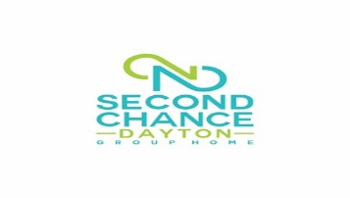

Strategic Plan

FY 2022
-
2027
(
updated November.
2021)

Mission Second Chance Dayton Group Home is dedicated to improving the quality of life of young men and women who may suffer from behavioral and/or emotional difficulties.
Vision Every person receives timely and effective mental health care.

SCD 2027
- The need for youth services will experience a large influx of children with extreme behaviors within the next 3-5 years.
- In a recent survey 57% of people living in a group home are not happy with their living situation.
- Of persons in group homes going on to higher education, 64% are unsuccessful.
- Social skills training was the most frequently requested service by families with children with RAD
- It is becoming increasingly difficult to balance the programmatic needs and desires of referring agency representatives with the need to be efficient and cost effective.
- There is a continuing need to nurture positive, professional relationships with referring agency representatives.

Key High-Level Strategies
- Continuing leadership and long term-viability providing comprehensive access/crisis intervention continuum of care through the collective effort of Second Chance Dayton and its Members.
- Scan the environment for opportunities to increase finances by 50% over the next three years.
- Become certified through Medicaid for mental health billing.
- Provide professional value-added consultation at the Members’ request and direction.
- Continue a CARF 3-year reaccreditation!
- Become certified through Ohio Department of Mental Health and Addiction Services
Strategic Objectives
Our Critical Success Factors & Key Goals

Clients & Program Services
- Help youth successfully complete our programs
- Help youth increase their sense of well-being
- Help youth increase levels of education, employment, and income
- Help youth develop positive connections

Internal Processes & Operations
- Deliver high-quality and coordinated client care
- Develop/expand collaborations with key strategic partners
- Foster client accountability/engagement using innovative approaches

People & Learning
- Live our core values
- Recruit, reward and recognize staff to drive retention and performance
- Provide effective training to enhance staff skillsets

Financial & Funding
- Grow revenue from government sources, including Medicaid fee-for-service
- Increase community engagement

